Unmanned Underwater Drones for Exploration and Protection Missions

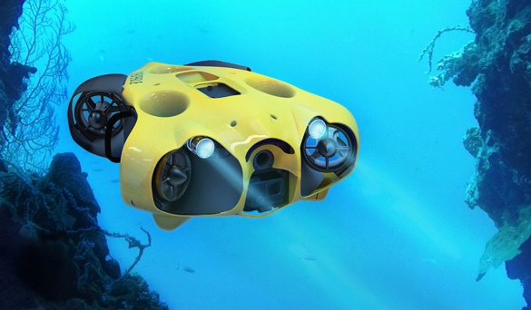
Most of the surface of the earth has been explored, but much of the underwater regions of Earth are largely uncharted, and moreover unprotected.
The aim of this assignment is to design the architecture of a system that can explore and protect a large underwater region.
This system consists of a group (between 2 and 5) unmanned underwater drones and a groundstation. The groundstation is managed by a group of rangers. For this assignment, we assume that there is a technology by which the underwater drones can wirelessly communicate with each other up to a distance of 50 meters from each other.
Each drone contains a battery and can propel itself autonomously. Of course, the action-radius of the drone is limited: one battery-charge can sustain a drone for 6 hours underwater. And the drone must return to the charging station before its battery runs out. In order to cover a larger area, there can be a few underwater charging stations on fixed locations. Because communication is limited to 50 meters, these underwater stations also function as a hub such that information can be forwarded over larger distances (in a store-and-forward manner).
Some of the functions/missions that this system must be able to perform are:
- M0: During every mission, each drone measures and logs various types of data from its surroundings, such as temperature, current, depth.
- M1: Produce a 3D map of the underwater terrain. For this the drones themselves split up a particular region and each drone handles one of the subregions. If a drone finds an underwater cave, it will call in the help of another drone.
- M2: Surveillance a region to make photographs and videos of interesting underwater plants and animals. For this each drone must be able to (gently!) follow an animal as it moves around.
- M3: The drone can recognize and count interesting animal that it encounters during a session.
- M4: Measure pollution, and then record time and place. This data is extracted from the drone once it returns to the ground station.
- M5: Protect: It can survey a particular region and for doing this, it can recognize scuba-divers. If it recognizes a scuba-diver, then it takes a photo, signals a sound and signals to the ground station to calls for an underwater ranger to come over to this location. In the meantime, the drone will follow the scuba-diver.
- M6: A drone can act as a support for a pair of rangers when they go on a scuba-mission. For this purpose, the drone can recognize a few hand-signals of the scuba-diver, such as: i) make a photo/video, ii) shine your torch here.
- M7: Search and Rescue: If due to some unforeseen circumstance/malfunction, a drone cannot revert back to the groundstation, then it will send out an emergency signal. The nearest other drone in the team will then pick up this drone and immediately return to the ground station.
On the surface there is a groundstation. This ground station continuously gets information about the positions and status of each of the drones. It displays this information on a large screen in the control room. Normally the rangers upload missions to drones before they are put in the water. But the ground station can also send missions to the drones (while the drones are underwater). The ground station can call individual drones back to the surface – e.g. if there is a concern about a defect in the mechanics of the drone.

