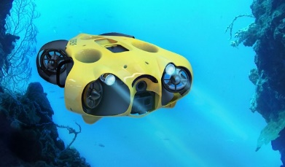
Assignment 3 – Underwater Drones
Task Instructions
Create a document that contains the following:
- Stakeholders (10 pts)
  - Describe the stakeholders of this system (describe at least 3, and at most 5 stakeholders)
  - For each stakeholder, describe one or more of his interest (‘stake’) in the system.

- Forces and Drivers (10 pts)
  - Describe at least 5 forces that apply to the design of this system.
  - Which of these forces do you think are architectural drivers? Explain why.
- Use case diagram (10 pts)
Create a use case diagram for this system.
The use case diagram should present the main interactions between the system and the users. The use case diagram should explicitly mention any external systems that are involved in this system.

- Components/Subsystems (10 pts)
  - Can you identify which subsystems will be needed in this system?
  - Give a concise description of the main responsibility of each subsystem.
Hint: avoid enumerating detailed functionality.
  - Design a model that represents the structural view for this system.
This model should present the main component/subsystems of the system and the relation between them.

- Architectural Style
Describe the architectural style(s) used in your design.
Motivate why your architecture uses this/these style(s).

- Sequence Diagrams
To create the sequence diagram/s, please consider the following use cases:
  - M1: Produce a 3D map
  - M3: Recognize and count animal
  - M6: Drone makes a photo when triggered by a ranger’s hand-signal

- Deployment Diagram
Please create one or more deployment diagram that represent the distribution of the components of the system on different machines (servers/ CUPs), and indicate how these machines are connected to each other.

- Risks
Mention 2 technical risks to this project.

